Report on Cyber Security Awareness Month
Session 3 on " Cyber Crime Investigation”

Title: “Guardians of the Digital realm”
Date: 20-10-2023
Time: 11.00 am to 12.00 pm : For ICEM/MCA Students
12:15 pm to 01:15 pm : For IGSB Students
Day: Friday
Venue: Chankya Auditorium

Resource Person: Mr. Ashish Dhone, Cyber Security Expert at Entel, South America
No of Attendees: 360
Notice/ Email Communication.: Telephonic and Online
Mode of Delivery: Offline
Type of event: Under Cyber Security Awareness Month Programs
Objective:
- Explore Real time hacking case scenarios.
- To understand dark web.
- Explore career path in this field.
Faculty in charge: NA
Learning Outcome:
- Students get to know about dark web and security measures.
- Students also see real time hacking which help them to understand how important is to secure data.
About Session:
The Indira Group of Institutes organized a session on "Cyber Security Awareness" for the students of institutes in Chanakya Campus as part of Cyber Security Awareness Month. The guest speaker for the session was Mr. Ashish Dhone. Sir give live demo of real time hacking, which is eye opener for students. Sir also explain numbers of ways through which engineering students or MBA students can enter into cyber security field. It was a very knowledgeable session for the students.

Glimpses:

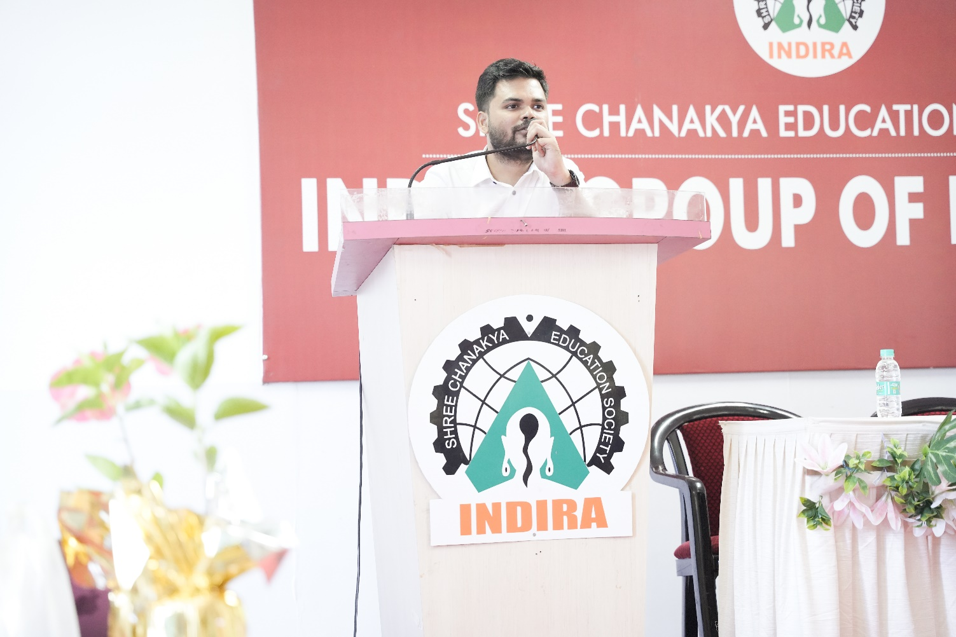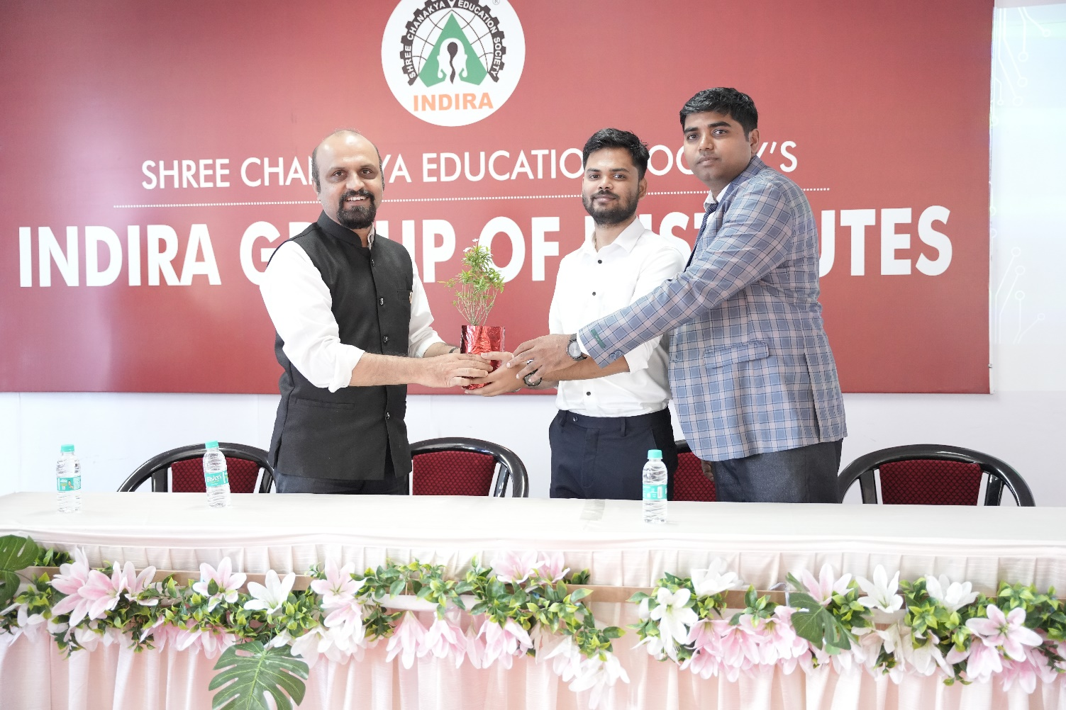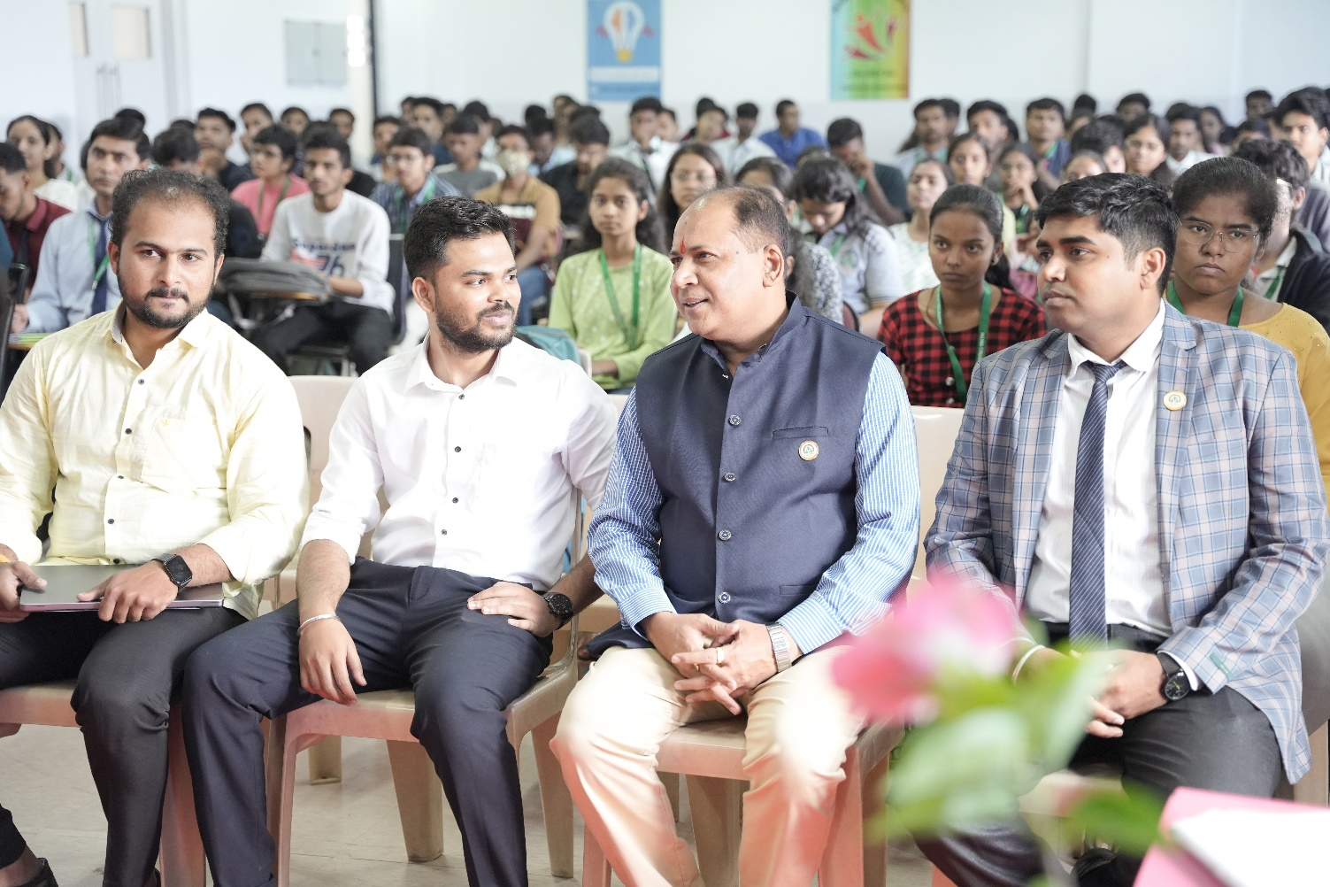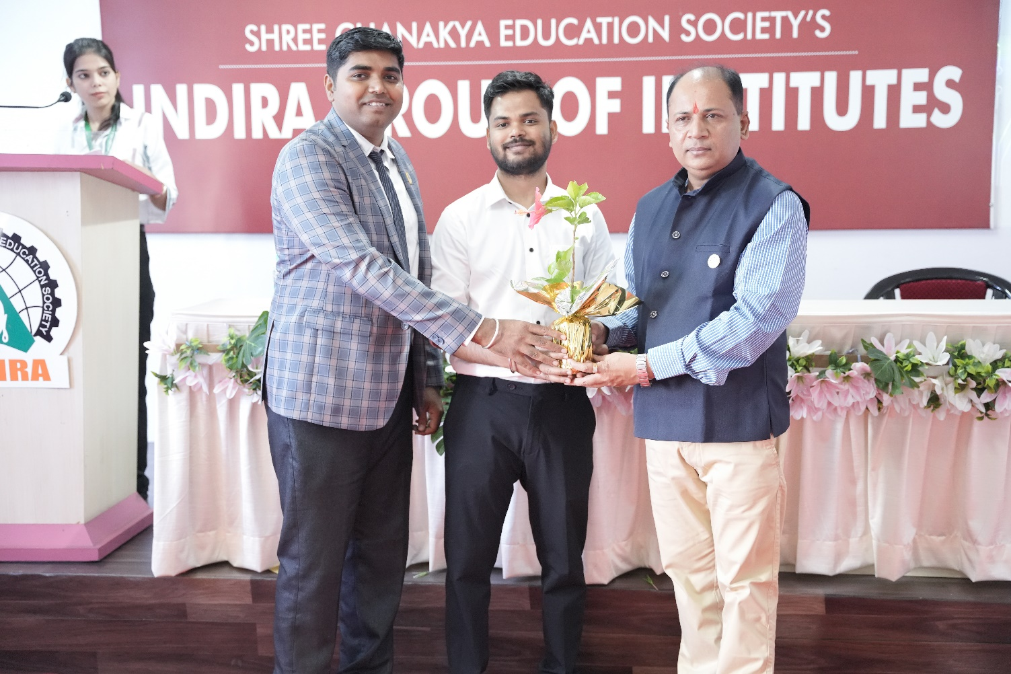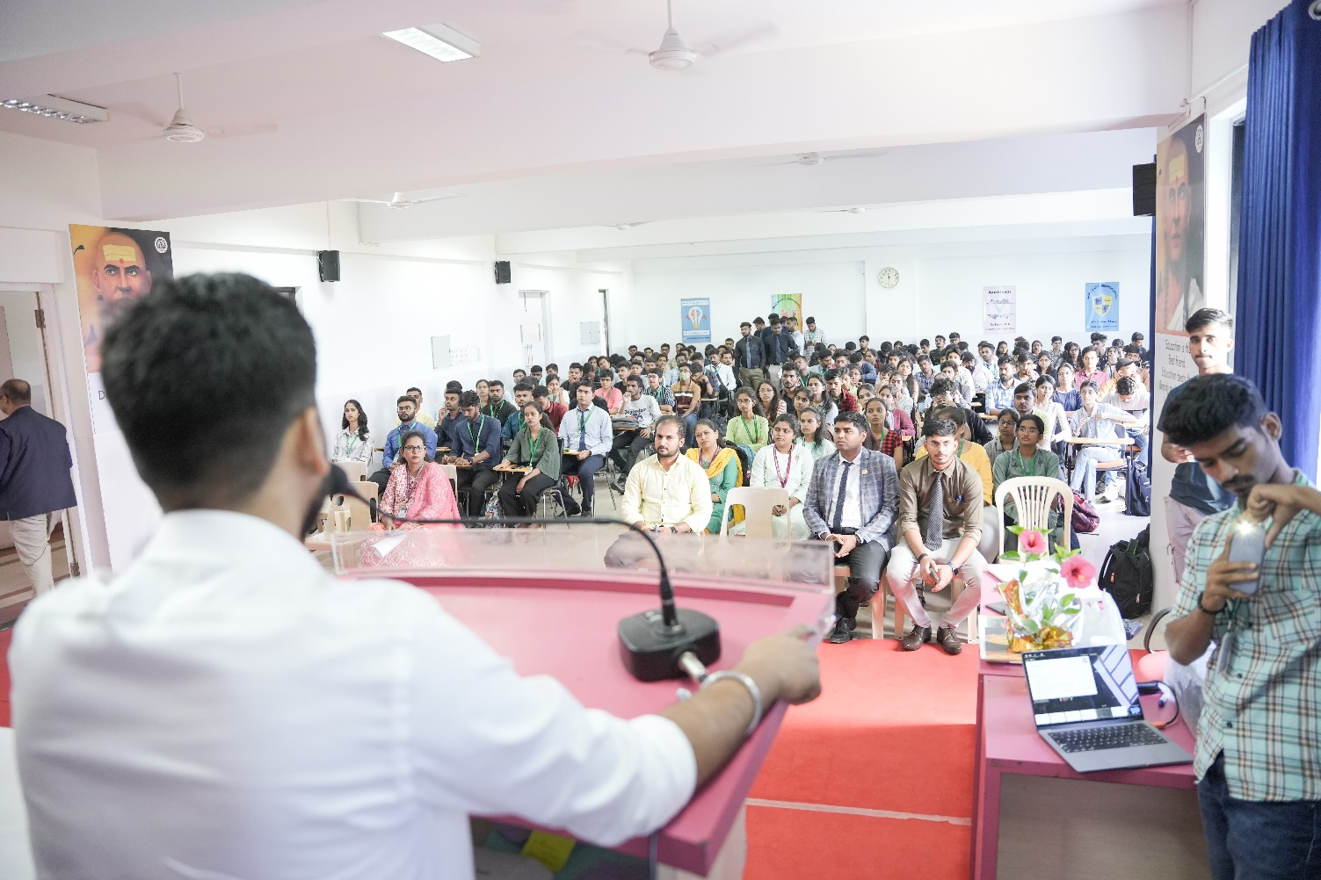

Guest Speaker: Session by Mr.Ashish Dhone

Feedback Summary of Guest Session:

FEEDBACK ANALYSIS:

ATTENDANCE:

